Aim: Develop a full stack web application using MERN stack to perform CRUD operations. Objectives:

Code:

Backend:

Server.js

const express = require("express");
const mongoose = require("mongoose");
const cors = require("cors");

const app = express();
const PORT = 5000;
const MONGO_URI = "mongodb://127.0.0.1:27017/studentdb";

// ── Middleware ────────────────────────────────────────
app.use(cors());
app.use(express.json());

// ── Routes ────────────────────────────────────────────
app.use("/api/students", require("./routes/students"));

// ── Connect to MongoDB & Start Server ─────────────────
mongoose.connect(MONGO_URI)
.then(() => {
console.log("✅ MongoDB connected!");
app.listen(PORT, () => {
console.log(`✅ Server running at http://localhost:${PORT}`);
console.log(`\n Endpoints:`);
console.log(` GET http://localhost:${PORT}/api/students`);
console.log(` GET http://localhost:${PORT}/api/students/:rollNo`);
console.log(` POST http://localhost:${PORT}/api/students`);
console.log(` PUT http://localhost:${PORT}/api/students/:rollNo`);
console.log(` DELETE http://localhost:${PORT}/api/students/:rollNo`);
});
})
.catch((err) => console.log("❌ MongoDB connection error:", err));

Routes-students.js

const express = require("express");
const router = express.Router();
const bcrypt = require("bcryptjs");
const Student = require("../models/Student");

// ── GET all students ──────────────────────────────────
router.get("/", async (req, res) => {
try {
const students = await Student.find().select("-password");
res.json({ success: true, count: students.length, data: students });
} catch (err) {
res.status(500).json({ success: false, message: err.message });
}
});

// ── GET one student by rollNo ─────────────────────────
router.get("/:rollNo", async (req, res) => {
try {
const student = await Student.findOne({ rollNo: req.params.rollNo }).select("-password");
if (!student) return res.status(404).json({ success: false, message: "Student not found" });
res.json({ success: true, data: student });
} catch (err) {
res.status(500).json({ success: false, message: err.message });
}
});

// ── POST create new student ───────────────────────────
router.post("/", async (req, res) => {
try {
const { firstName, lastName, rollNo, password, confirmPassword, contact } = req.body;

// Validation
if (!firstName || !lastName || !rollNo || !password || !confirmPassword || !contact)
return res.status(400).json({ success: false, message: "All fields are required" });

if (!/^[A-Za-z ]+$/.test(firstName) || !/^[A-Za-z ]+$/.test(lastName))
return res.status(400).json({ success: false, message: "Names must contain only letters" });

if (password.length < 6)
return res.status(400).json({ success: false, message: "Password must be at least 6 characters" });

if (password !== confirmPassword)
return res.status(400).json({ success: false, message: "Passwords do not match" });

if (!/^[0-9]{10}$/.test(contact))
return res.status(400).json({ success: false, message: "Contact must be exactly 10 digits" });

// Check duplicate rollNo
const existing = await Student.findOne({ rollNo });
if (existing)
return res.status(400).json({ success: false, message: `Roll No '${rollNo}' already exists` });

// Hash password
const hashed = await bcrypt.hash(password, 10);

const student = await Student.create({ firstName, lastName, rollNo, password: hashed, contact });
res.status(201).json({ success: true, message: "Student registered successfully", data: { ...student._doc, password: undefined } });
} catch (err) {
res.status(500).json({ success: false, message: err.message });
}
});

// ── PUT update student by rollNo ──────────────────────
router.put("/:rollNo", async (req, res) => {
try {
const { firstName, lastName, contact, newPassword, confirmPassword } = req.body;

if (!firstName || !lastName || !contact)
return res.status(400).json({ success: false, message: "First name, last name and contact are required" });

if (!/^[A-Za-z ]+$/.test(firstName) || !/^[A-Za-z ]+$/.test(lastName))
return res.status(400).json({ success: false, message: "Names must contain only letters" });

if (!/^[0-9]{10}$/.test(contact))
return res.status(400).json({ success: false, message: "Contact must be exactly 10 digits" });

const updateData = { firstName, lastName, contact };

if (newPassword) {
if (newPassword.length < 6)
return res.status(400).json({ success: false, message: "Password must be at least 6 characters" });
if (newPassword !== confirmPassword)
return res.status(400).json({ success: false, message: "Passwords do not match" });
updateData.password = await bcrypt.hash(newPassword, 10);
}

const student = await Student.findOneAndUpdate(
{ rollNo: req.params.rollNo },
updateData,
{ new: true }
).select("-password");

if (!student)
return res.status(404).json({ success: false, message: "Student not found" });

res.json({ success: true, message: "Student updated successfully", data: student });
} catch (err) {
res.status(500).json({ success: false, message: err.message });
}
});

// ── DELETE student by rollNo ──────────────────────────
router.delete("/:rollNo", async (req, res) => {
try {
const student = await Student.findOneAndDelete({ rollNo: req.params.rollNo });
if (!student)
return res.status(404).json({ success: false, message: "Student not found" });
res.json({ success: true, message: `Student '${req.params.rollNo}' deleted successfully` });
} catch (err) {
res.status(500).json({ success: false, message: err.message });
}
});

module.exports = router;
models-students.js

const mongoose = require("mongoose");

const studentSchema = new mongoose.Schema({
firstName: { type: String, required: true, trim: true },
lastName: { type: String, required: true, trim: true },
rollNo: { type: String, required: true, unique: true, trim: true },
password: { type: String, required: true },
contact: { type: String, required: true },
}, { timestamps: true });

module.exports = mongoose.model("Student", studentSchema);

Frontend:

App.js

import { useState } from "react";
import Register from "./components/Register";
import Update from "./components/Update";
import ViewAll from "./components/ViewAll";
import "./App.css";

function App() {
const [tab, setTab] = useState("register");

return (
<div className="app">
<header>
<h1>🎓 Student Registration System</h1>
<span className="stack-badge">MERN Stack</span>
</header>

<div className="tabs">
<button className={`tab-btn ${tab === "register" ? "active" : ""}`} onClick={() => setTab("register")}>📝 Register</button>
<button className={`tab-btn ${tab === "update" ? "active" : ""}`} onClick={() => setTab("update")}>✏️ Update</button>
<button className={`tab-btn ${tab === "view" ? "active" : ""}`} onClick={() => setTab("view")}>📋 View All</button>
</div>

<div className="content">
{tab === "register" && <Register />}
{tab === "update" && <Update />}
{tab === "view" && <ViewAll />}
</div>
</div>
);
}

export default App;

app.css

@import url('https://fonts.googleapis.com/css2?family=DM+Serif+Display&family=DM+Sans:wght@300;400;500;600&display=swap');

*, *::before, *::after { box-sizing: border-box; margin: 0; padding: 0; }

:root {
--navy: #0f1b2d;
--blue: #1a56db;
--green: #10b981;
--red: #ef4444;
--cream: #f8f5ef;
--border: #e5e7eb;
--shadow: 0 4px 24px rgba(15,27,45,.10);
}

body {
font-family: 'DM Sans', sans-serif;
background: var(--cream);
color: var(--navy);
min-height: 100vh;
}

/* ── Header ── */
header {
background: var(--navy);
color: #fff;
padding: 0 40px;
height: 68px;
display: flex;
align-items: center;
justify-content: space-between;
position: sticky; top: 0; z-index: 100;
}
header h1 { font-family: 'DM Serif Display', serif; font-size: 1.45rem; }
.stack-badge {
background: var(--blue);
color: #fff;
font-size: .72rem;
font-weight: 600;
padding: 4px 12px;
border-radius: 20px;
letter-spacing: .5px;
}

/* ── Tabs ── */
.tabs {
display: flex;
gap: 4px;
background: #fff;
border-bottom: 2px solid var(--border);
padding: 0 40px;
}
.tab-btn {
padding: 14px 22px;
border: none;
background: none;
font-family: 'DM Sans', sans-serif;
font-size: .9rem;
font-weight: 500;
cursor: pointer;
color: #6b7280;
border-bottom: 3px solid transparent;
margin-bottom: -2px;
transition: all .2s;
}
.tab-btn.active { color: var(--blue); border-bottom-color: var(--blue); }
.tab-btn:hover:not(.active) { color: var(--navy); background: var(--cream); }

/* ── Content ── */
.content {
max-width: 1000px;
margin: 0 auto;
padding: 32px 24px;
}

/* ── Card ── */
.card {
background: #fff;
border-radius: 14px;
border: 1px solid var(--border);
padding: 28px;
margin-bottom: 24px;
box-shadow: var(--shadow);
}
.card-title {
font-family: 'DM Serif Display', serif;
font-size: 1.15rem;
margin-bottom: 22px;
padding-bottom: 14px;
border-bottom: 1px solid var(--border);
}

/* ── Form ── */
.form-grid {
display: grid;
grid-template-columns: 1fr 1fr;
gap: 16px;
}
.form-group { display: flex; flex-direction: column; gap: 5px; }
.form-group.full { grid-column: span 2; }

label {
font-size: .78rem;
font-weight: 600;
text-transform: uppercase;
letter-spacing: .4px;
color: #6b7280;
}
input {
padding: 10px 13px;
border: 1.5px solid var(--border);
border-radius: 8px;
font-family: 'DM Sans', sans-serif;
font-size: .93rem;
outline: none;
transition: border-color .2s;
}
input:focus { border-color: var(--blue); box-shadow: 0 0 0 3px rgba(26,86,219,.08); }
input.err { border-color: var(--red); }
input[readOnly] { background: #f9fafb; color: #6b7280; }

.field-err { font-size: .77rem; color: var(--red); margin-top: 2px; }

/* ── Buttons ── */
.btn {
padding: 11px 26px;
border: none;
border-radius: 8px;
font-family: 'DM Sans', sans-serif;
font-size: .92rem;
font-weight: 600;
cursor: pointer;
transition: all .2s;
}
.btn-primary { background: var(--blue); color: #fff; }
.btn-primary:hover { background: #1447c2; transform: translateY(-1px); }
.btn-danger { background: var(--red); color: #fff; }
.btn-danger:hover { background: #dc2626; }
.btn-warning { background: #f59e0b; color: #fff; }
.btn-warning:hover { background: #d97706; }
.btn-outline { background: transparent; border: 2px solid var(--navy); color: var(--navy); }
.btn-outline:hover { background: var(--navy); color: #fff; }

/* ── Alert ── */
.alert {
padding: 12px 16px;
border-radius: 8px;
font-weight: 500;
font-size: .9rem;
margin-bottom: 18px;
}
.alert-success { background: #d1fae5; color: #065f46; border: 1px solid #a7f3d0; }
.alert-error { background: #fee2e2; color: #991b1b; border: 1px solid #fecaca; }

/* ── Table ── */
.table-wrap { overflow-x: auto; border-radius: 10px; border: 1px solid var(--border); }
table { width: 100%; border-collapse: collapse; font-size: .88rem; }
thead { background: var(--navy); color: #fff; }
th { padding: 12px 14px; text-align: left; font-weight: 500; font-size: .76rem; text-transform: uppercase; letter-spacing: .5px; }
td { padding: 12px 14px; border-bottom: 1px solid #f3f4f6; }
tr:last-child td { border-bottom: none; }
tr:hover td { background: #f8faff; }

.roll-badge {
display: inline-block;
background: #eff6ff;
color: var(--blue);
font-size: .75rem;
font-weight: 600;
padding: 2px 9px;
border-radius: 20px;
}
.empty-state { text-align: center; padding: 48px; color: #9ca3af; }
.empty-state span { font-size: 2.5rem; display: block; margin-bottom: 10px; }

.del-row { display: flex; gap: 12px; align-items: flex-end; flex-wrap: wrap; }
.del-row .form-group { flex: 1; min-width: 200px; }

@media(max-width: 650px) {
.form-grid { grid-template-columns: 1fr; }
.form-group.full { grid-column: span 1; }
.content { padding: 20px 16px; }
header { padding: 0 16px; }
.tabs { padding: 0 8px; }
}

Components:

Regester.js

import { useState } from "react";
import axios from "axios";

const API = "http://localhost:5000/api/students";

const init = { firstName:"", lastName:"", rollNo:"", password:"", confirmPassword:"", contact:"" };

export default function Register() {
const [form, setForm] = useState(init);
const [errors, setErrors] = useState({});
const [alert, setAlert] = useState(null);

const handle = (e) => setForm({ ...form, [e.target.name]: e.target.value });

const validate = () => {
const e = {};
if (!form.firstName.trim()) e.firstName = "Required";
else if (!/^[A-Za-z ]+$/.test(form.firstName)) e.firstName = "Letters only";
if (!form.lastName.trim()) e.lastName = "Required";
else if (!/^[A-Za-z ]+$/.test(form.lastName)) e.lastName = "Letters only";
if (!form.rollNo.trim()) e.rollNo = "Required";
if (form.password.length < 6) e.password = "Min 6 characters";
if (form.password !== form.confirmPassword) e.confirmPassword = "Passwords do not match";
if (!/^[0-9]{10}$/.test(form.contact)) e.contact = "Must be 10 digits";
return e;
};

const submit = async () => {
const e = validate();
if (Object.keys(e).length) { setErrors(e); return; }
setErrors({});
try {
await axios.post(API, form);
setAlert({ type:"success", msg:"✅ Student registered successfully!" });
setForm(init);
} catch (err) {
setAlert({ type:"error", msg:"❌ " + (err.response?.data?.message || "Server error") });
}
};

const field = (name, label, type="text", placeholder="") => (
<div className="form-group">
<label>{label} *</label>
<input
type={type} name={name} value={form[name]}
placeholder={placeholder} onChange={handle}
className={errors[name] ? "err" : ""}
/>
{errors[name] && <span className="field-err">{errors[name]}</span>}
</div>
);

return (
<div className="card">
<div className="card-title">New Student Registration</div>
{alert && <div className={`alert alert-${alert.type}`}>{alert.msg}</div>}
<div className="form-grid">
{field("firstName", "First Name", "text", "e.g. Ravi")}
{field("lastName", "Last Name", "text", "e.g. Sharma")}
{field("rollNo", "Roll No / ID", "text", "e.g. CS2024001")}
{field("contact", "Contact Number", "tel", "10-digit mobile")}
{field("password", "Password", "password", "Min 6 characters")}
{field("confirmPassword", "Confirm Password", "password", "Repeat password")}
<div className="form-group full" style={{ marginTop: 8 }}>
<button className="btn btn-primary" onClick={submit}>➕ Register Student</button>
</div>
</div>
</div>
);
}

Update.js

import { useState } from "react";
import axios from "axios";

const API = "http://localhost:5000/api/students";

export default function Update() {
const [searchRoll, setSearchRoll] = useState("");
const [student, setStudent] = useState(null);
const [form, setForm] = useState({});
const [errors, setErrors] = useState({});
const [alert, setAlert] = useState(null);

const search = async () => {
if (!searchRoll.trim()) return;
try {
const res = await axios.get(`${API}/${searchRoll}`);
const s = res.data.data;
setStudent(s);
setForm({ firstName: s.firstName, lastName: s.lastName, contact: s.contact, newPassword: "", confirmPassword: "" });
setAlert(null); setErrors({});
} catch {
setStudent(null);
setAlert({ type:"error", msg:`❌ No student found with Roll No: ${searchRoll}` });
}
};

const handle = (e) => setForm({ ...form, [e.target.name]: e.target.value });

const validate = () => {
const e = {};
if (!form.firstName.trim()) e.firstName = "Required";
else if (!/^[A-Za-z ]+$/.test(form.firstName)) e.firstName = "Letters only";
if (!form.lastName.trim()) e.lastName = "Required";
else if (!/^[A-Za-z ]+$/.test(form.lastName)) e.lastName = "Letters only";
if (!/^[0-9]{10}$/.test(form.contact)) e.contact = "Must be 10 digits";
if (form.newPassword && form.newPassword.length < 6) e.newPassword = "Min 6 characters";
if (form.newPassword && form.newPassword !== form.confirmPassword) e.confirmPassword = "Passwords do not match";
return e;
};

const update = async () => {
const e = validate();
if (Object.keys(e).length) { setErrors(e); return; }
setErrors({});
try {
await axios.put(`${API}/${student.rollNo}`, form);
setAlert({ type:"success", msg:"✅ Student updated successfully!" });
} catch (err) {
setAlert({ type:"error", msg:"❌ " + (err.response?.data?.message || "Server error") });
}
};

const field = (name, label, type="text", placeholder="", readOnly=false) => (
<div className="form-group">
<label>{label}</label>
<input
type={type} name={name} value={form[name] ?? ""}
placeholder={placeholder} onChange={handle}
readOnly={readOnly}
className={errors[name] ? "err" : ""}
/>
{errors[name] && <span className="field-err">{errors[name]}</span>}
</div>
);

return (
<>
<div className="card">
<div className="card-title">🔍 Search Student by Roll No</div>
<div className="del-row">
<div className="form-group">
<label>Roll No / ID</label>
<input type="text" value={searchRoll} onChange={e => setSearchRoll(e.target.value)}
placeholder="e.g. CS2024001" style={{ width: 260 }} />
</div>
<button className="btn btn-warning" onClick={search}>🔍 Search</button>
</div>
</div>

{alert && !student && <div className={`alert alert-${alert.type}`}>{alert.msg}</div>}

{student && (
<div className="card">
<div className="card-title">✏️ Update Details — {student.firstName} {student.lastName}</div>
{alert && <div className={`alert alert-${alert.type}`}>{alert.msg}</div>}
<div className="form-grid">
{field("firstName", "First Name *")}
{field("lastName", "Last Name *")}
<div className="form-group">
<label>Roll No (Read-only)</label>
<input type="text" value={student.rollNo} readOnly />
</div>
{field("contact", "Contact Number *", "tel", "10-digit mobile")}
{field("newPassword", "New Password", "password", "Leave blank to keep current")}
{field("confirmPassword", "Confirm Password", "password", "Repeat new password")}
<div className="form-group full" style={{ marginTop: 8, display:"flex", gap:12 }}>
<button className="btn btn-primary" onClick={update}>💾 Save Changes</button>
<button className="btn btn-outline" onClick={() => { setStudent(null); setSearchRoll(""); setAlert(null); }}>Cancel</button>
</div>
</div>
</div>
)}
</>
);
}

Viewall.js

import { useState, useEffect } from "react";
import axios from "axios";

const API = "http://localhost:5000/api/students";

export default function ViewAll() {
const [students, setStudents] = useState([]);
const [alert, setAlert] = useState(null);
const [delRoll, setDelRoll] = useState("");

const fetchAll = async () => {
try {
const res = await axios.get(API);
setStudents(res.data.data);
} catch {
setAlert({ type:"error", msg:"❌ Could not fetch students. Is the server running?" });
}
};

useEffect(() => { fetchAll(); }, []);

const deleteStudent = async () => {
if (!delRoll.trim()) { setAlert({ type:"error", msg:"❌ Please enter a Roll No." }); return; }
if (!window.confirm(`Delete student with Roll No: ${delRoll}?`)) return;
try {
await axios.delete(`${API}/${delRoll}`);
setAlert({ type:"success", msg:`✅ Student '${delRoll}' deleted successfully.` });
setDelRoll("");
fetchAll();
} catch (err) {
setAlert({ type:"error", msg:"❌ " + (err.response?.data?.message || "Student not found") });
}
};

return (
<>
{/* Delete section */}
<div className="card">
<div className="card-title">🗑️ Delete Student by Roll No</div>
{alert && <div className={`alert alert-${alert.type}`}>{alert.msg}</div>}
<div className="del-row">
<div className="form-group">
<label>Roll No / ID</label>
<input type="text" value={delRoll} onChange={e => setDelRoll(e.target.value)}
placeholder="Enter Roll No to delete" style={{ width: 260 }} />
</div>
<button className="btn btn-danger" onClick={deleteStudent}>🗑️ Delete Student</button>
</div>
</div>

{/* Table */}
<div className="card">
<div className="card-title" style={{ display:"flex", justifyContent:"space-between", alignItems:"center" }}>
<span>📋 All Students</span>
<button className="btn btn-outline" style={{ padding:"6px 14px", fontSize:".82rem" }} onClick={fetchAll}>🔄 Refresh</button>
</div>

{students.length === 0 ? (
<div className="empty-state"><span>📭</span>No students registered yet.</div>
) : (
<div className="table-wrap">
<table>
<thead>
<tr>
<th>#</th>
<th>Roll No</th>
<th>First Name</th>
<th>Last Name</th>
<th>Contact</th>
</tr>
</thead>
<tbody>
{students.map((s, i) => (
<tr key={s._id}>
<td>{i + 1}</td>
<td><span className="roll-badge">{s.rollNo}</span></td>
<td>{s.firstName}</td>
<td>{s.lastName}</td>
<td>{s.contact}</td>
</tr>
))}
</tbody>
</table>
</div>
)}
</div>
</>
);
}

Output:

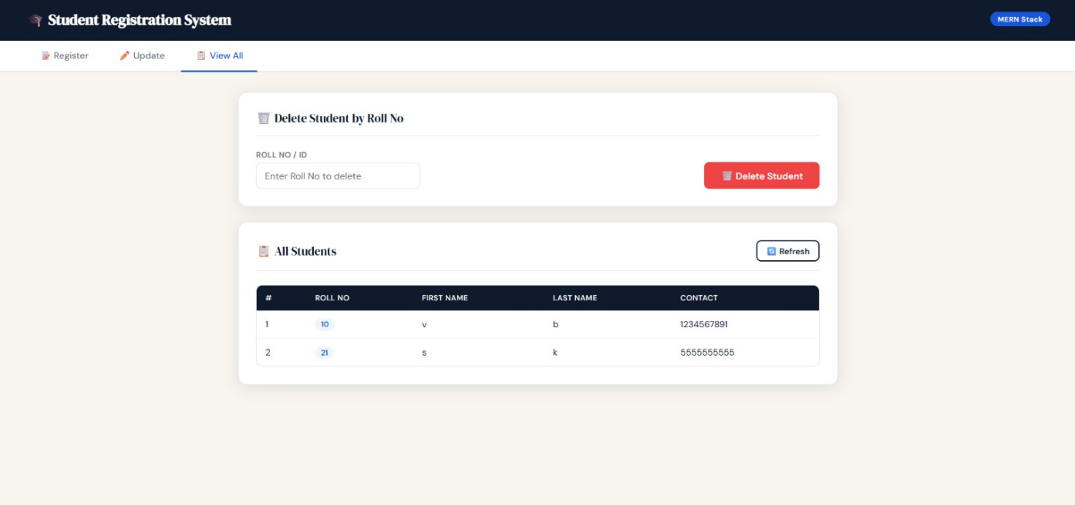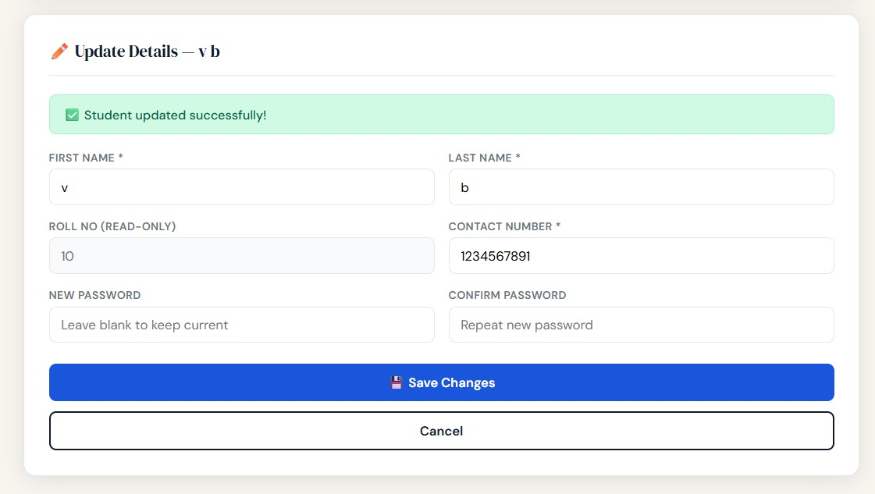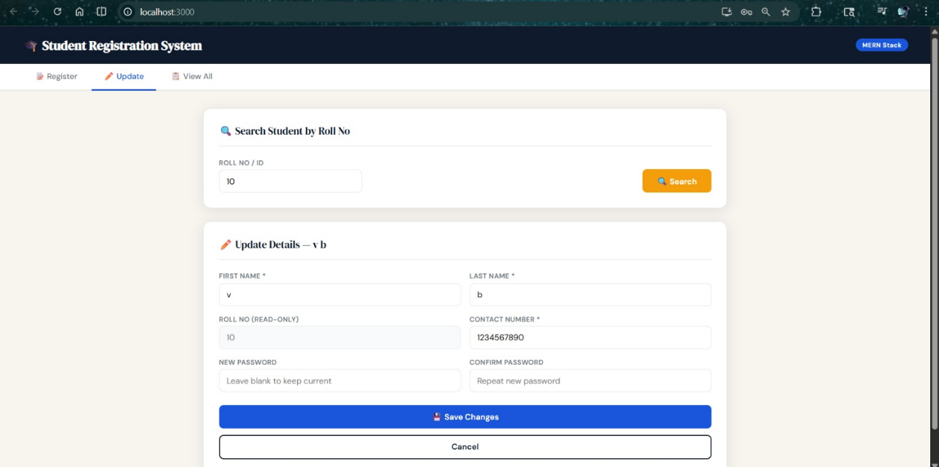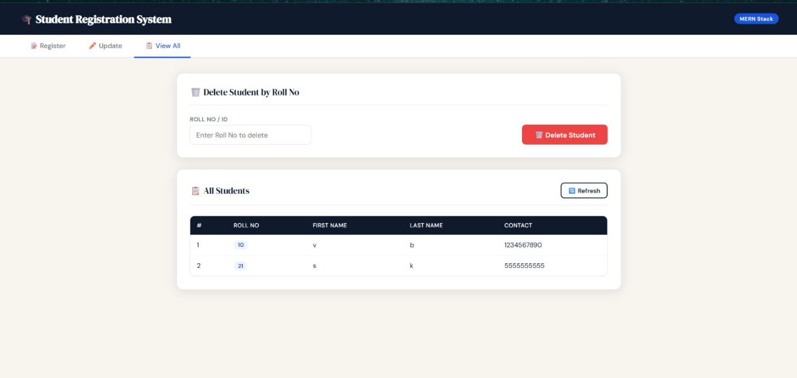

FAQ:

